Time Series Forecasting

1. **Coco Cola Raw Dataset:**

Quarterly Sales given per year.

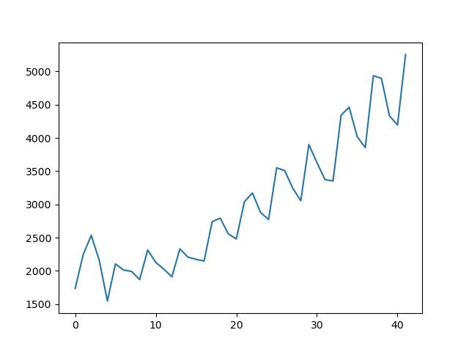

Definite Trend, Seasonality Observed after 10 Time period. Constant trend .

Models Used **:: Exponential Smoothing** since there is a period where there is not constant trend present to confidently say that it follows upward trend.

Moving Average to show trend analysis.

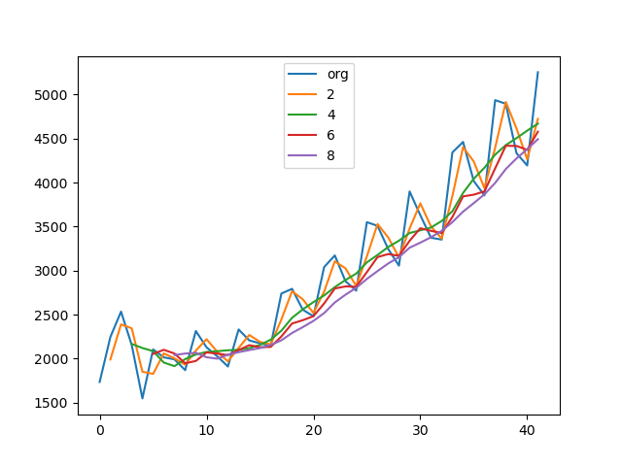

Decomposing the Data for making it stationary when its Seasonal:

1. Additive

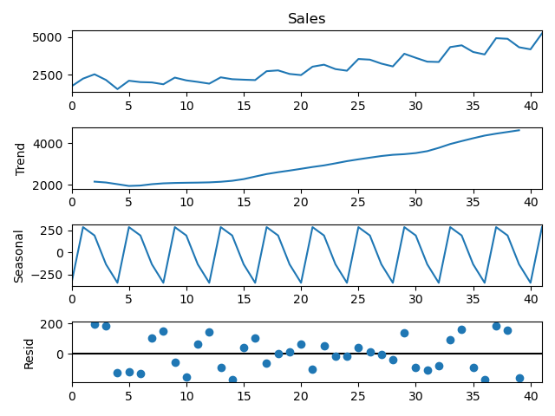

The residual for Additive is varied.

1. Multiplicative :

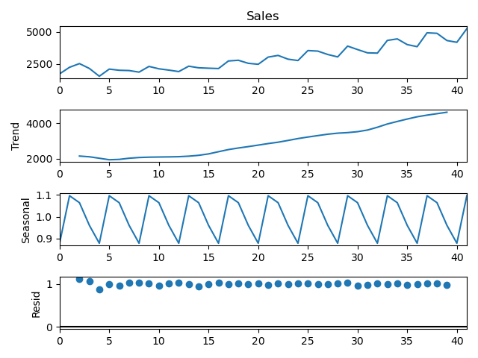

The residuals are shifter up in multiplicative decomposing.

The Autocorrelation Plots and Partial ACF to get the Autoregressive and Moving Averages (p, q)

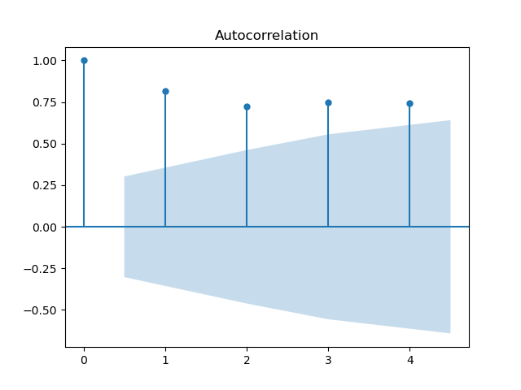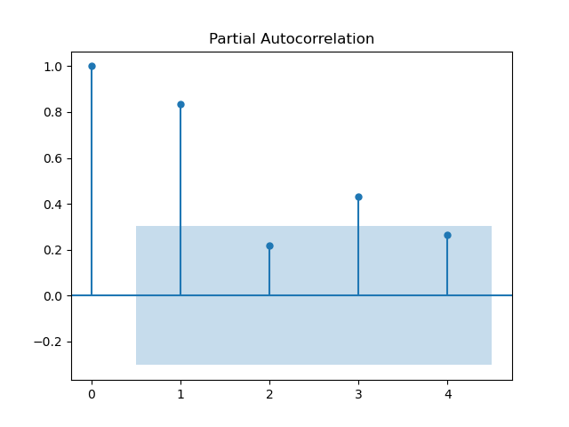

Comparing the Mean Abs Percentage Error Forecast for Simple Expo , holts , Holts winter

#28.28529617659357 --- Simple Expo

#35.30989441123007 ----holts

#27.903811698151365 - ---Winters with Additive Seasonality and Additive Trend

#32.691647924705855 ------Winters with exponential smoothing with multiplicative seasonality and additive trend

,In this case 27.903811698151365 - ---Winters with Additive Seasonality and Additive Trend has the lowest error for forecasting.

1. **Airline Dataset::** Seasonal Data by plotting the graph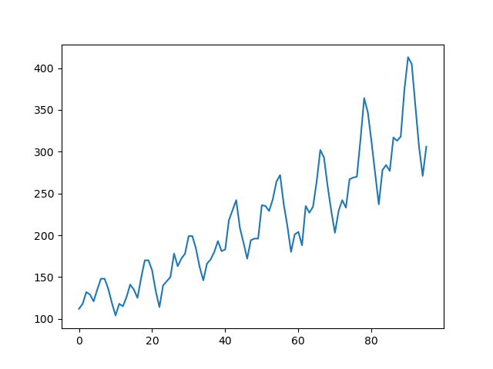

Same Seasonal data pattern observed after every year.

Models Used ::: SARIMA ,Detecting stationarity with ADFuller test (Hypothesis testing),Differencing

# Test for Stationarity by ADFuller Test by hypotheisis testing

#Ho - it is Non stationary

# H1 - It is stationary

p -value is 0.9 .So data is Stationary.

Differencing to remove Stationarity( to 12 month because in plot the seasonal is after every 12 months)

Differencing to remove Stationarity( to 12 month because in plot the seasonal is after every 12 months)

air['Seasonal first differnce '] = air["Passengers"] -air["Passengers"].shift(12)

p-value : 0.07578397625851772 .So here we reject Null Hypothesis and say that data is stationary

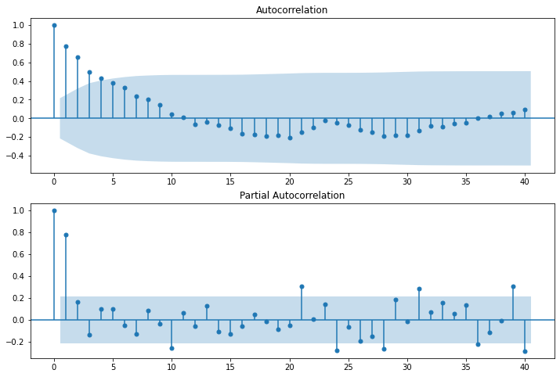

# for AR the shuts off happens at 1 and for MA the exponential decrease within the blue part is still 3

# (p =1 , q =3 )

Trying with ARIMA :Plot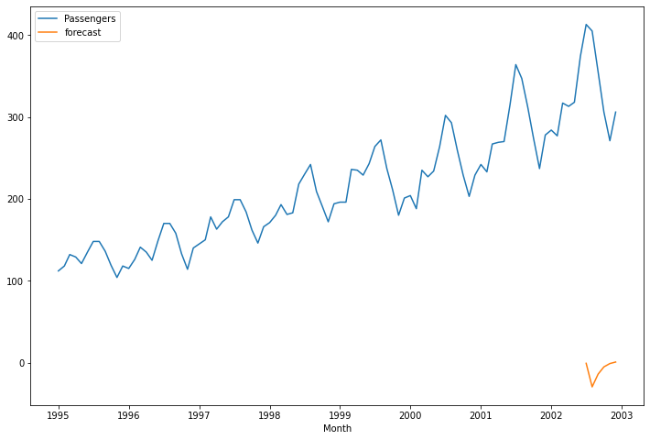

order=(1,1,3)

Time span given as start:80 end :100 to predict ,we get the above plot.

Trying with SARIMA:

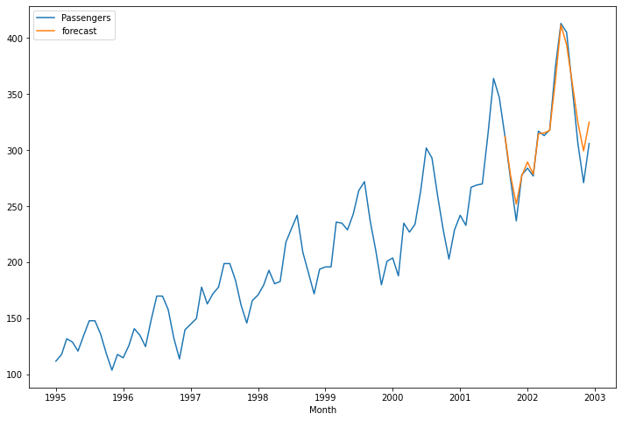

Much better predictions than ARIMA since its Seasonal Data for Airline Passengers.

FUTURE PREDICTIONS USING SARIMA :

Create a dataset from Dummy dataframe

########################### predict using SARIMA model

future_df['forecast'] = model_sarima_fit.predict(start = 80, end = 120, dynamic= True)

future_df[['Passengers', 'forecast']].plot(figsize=(12, 8))

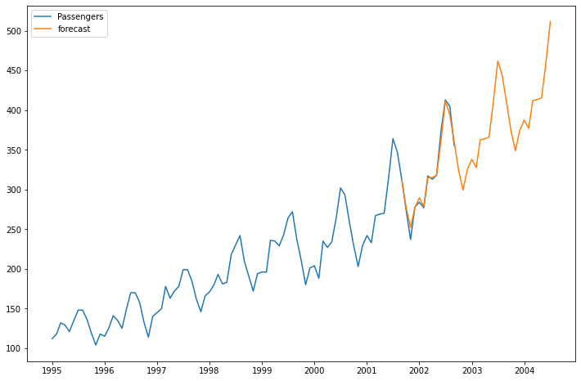

For the next years 2002 and 2004 the predictions are accurately done by SARIMA.